DATA ANALYST INTERNSHIP PROJECT
Banking Customer & Loan Analytics
Final Business Report
Prepared for: Bank Management
Prepared by: Junior Data Analyst
Data coverage: customers (2018–2026), transactions (Jan 2022 – Jun 2026), loans (Jan 2019 – Jun 2026)
Tools used: Python, NumPy, Pandas, Matplotlib, Seaborn

Scope note. This report summarises the work completed in the four project notebooks: Python & NumPy data understanding, Pandas data cleaning, exploratory data analysis, and the twelve final business questions (Q16–Q27). All figures come from those notebooks. Monetary values are shown in the dataset’s currency units (the city names suggest NPR) and are not converted.

1. Executive Summary
The bank serves one million customers who hold 1.3 million accounts and about 160.7 billion in deposits. It has issued 500,000 loans worth about 524.4 billion, and processed almost five million valid transactions worth 28.9 billion between January 2022 and June 2026. The key indicators are shown below.
1,000,000  Customers (after removing 2,000 duplicates) | 160.70 B  Total deposits (account balances) | 524.41 B  Total loans issued (500,000 loans)
4,999,900  Valid transactions (value 28.87 B) | 123,612  Average account balance | 1,048,824  Average loan amount

The most important findings:
- Middle-income customers carry the portfolio. Lower-Middle (25k–50k income) and Upper-Middle (50k–100k) customers make up 78% of customers, 78.5% of deposits and 78.6% of loan value. High-income customers are only 7.3% of the base.
- Customer value is driven by headcount, not income. Average deposits per customer (about 160,000) and loans per customer (about 520,000) are almost identical across all four income segments.
- Mobile is the leading channel. Mobile handles 25.0% of transactions; with Internet Banking it handles 43%. Branch counters handle only 12%.
- Personal loans dominate lending. They are 28.0% of loans and 27.9% of loan value, ahead of Home (18.1%) and Business (17.0%).
- Credit quality needs attention. 9.97% of all loans (49,843) are Defaulted. Under our rule-based score, 104,064 customers (10.4%) show a High Risk Indicator.
- Income and interest rate do not explain borrowing or repayment. Correlations are about 0.002 and 0.001. Higher-income customers do not take larger loans, and higher interest rates do not coincide with weaker repayment.
- Branches perform very evenly. BR039 leads on deposits (3.27 B) and BR024 on loan value (13.92 B), but the gap between leading and typical branches is small. BR027 and BR007 stand out as high-deposit, low-lending branches.
- Growth is flat. New customers (about 9,000–10,200 a month), deposits, lending and transactions have fluctuated within narrow bands with no sustained upward trend.
Data caution. Many breakdowns (cities, occupations, account types, branches, interest-rate groups) differ by only 1–2%. Rankings in this report are accurate, but the gaps are small, so they should be read as “broadly even” rather than as strong performance differences. The loan book is also about 3.3 times the deposit base, which should be validated before any liquidity conclusions are drawn (see Section 10).

2. Data and Methodology
Five relational datasets were provided: customers, accounts, transactions, loans and branches. The raw files were never modified; cleaning was done on working copies and saved to a separate cleaned folder.
Dataset | Raw rows | Cleaned rows | Main cleaning action
Customers | 1,002,000 | 1,000,000 | Removed 2,000 duplicate CustomerIDs; filled missing City (1,003) and Occupation (2,004) with “Unknown”; left 1,000 missing Income as null
Accounts | 1,300,000 | 1,300,000 | Converted Balance and OpenDate; standardised account types
Transactions | 5,000,000 | 4,999,900 | Removed 100 invalid amounts (all equal to −1)
Loans | 500,000 | 500,000 | No invalid amounts found; standardised types and statuses
Branches | 50 | 50 | Standardised text; no missing values

Referential integrity checks found no accounts or loans pointing to unknown customers and no transactions pointing to unknown accounts. The analysis then followed the project workflow: NumPy profiling, exploratory analysis with 15 required charts, advanced risk analysis, and twelve final business questions.

Data-quality notes for the next stage
- Branch ID casing. The cleaning step title-cased the branches file (“Br001”), while accounts use “BR001”. This produced the “50 unknown branches” result in the integrity check. Branch IDs should be upper-cased before SQL joins or Tableau relationships are built. The same title-casing turned channel names into “Atm”, “Pos” and “Qr” in the cleaned transactions.
- Loan amount ceiling. The maximum loan is exactly 30,000,000 and several customers sit at that value, which suggests a cap in the source system.
- Skewed distributions. Account balances (median 74,885 vs mean 123,612) and transaction amounts (median 3,499 vs mean 5,773, maximum 500,000) are strongly right-skewed, so medians are the better measure of a typical value.

3. Customer Insights

3.1 Who the customers are
- Average age is 36.2 years (range 18–75). Gender split is 49.1% male, 48.9% female and 2.0% other.
- Average income is 52,339, but the median is only 45,032 (25th–75th percentile: 31,069–65,205; maximum 620,227). A small number of high earners pull the average up.
- Customers are spread almost evenly across cities: each of the top ten cities has 66,500–67,000 customers (about 6.7% each). Pokhara (66,995), Nepalgunj (66,897) and Bharatpur (66,821) lead, by a very small margin.
- Salaried customers are the largest occupation group (28.0%), followed by Business (16.0%), Self-Employed (11.9%), Farmer (10.0%), Student (10.0%), Government (9.9%), Unemployed (8.0%) and Retired (6.0%).
- Average income is almost the same for every occupation (52,200–52,500). Students and unemployed customers report the same income as salaried staff, which is unusual and worth checking with the data owner.
- 39.3% of customers (393,109) have at least one loan; borrowers hold 1.27 loans on average.
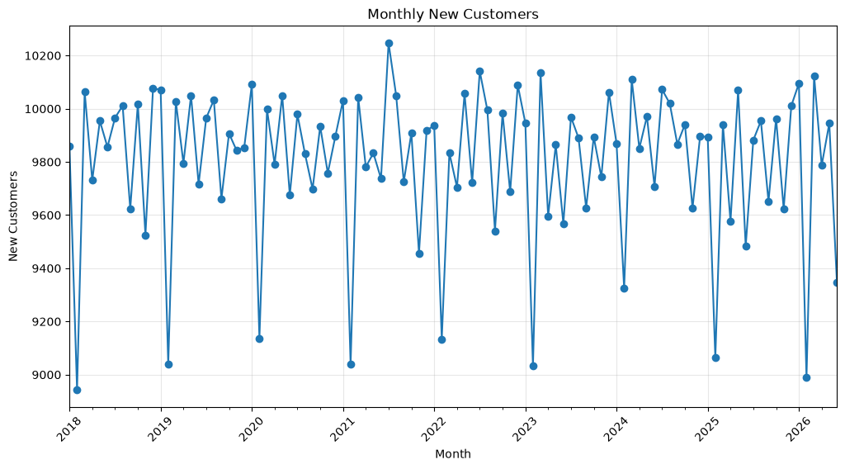
Figure 1. Monthly new customers, January 2018 – June 2026 (flat at roughly 9,000–10,200; February is consistently lowest)

3.2 Which customer segment is most valuable?
Customers were grouped by income (Low under 25k, Lower-Middle 25k–50k, Upper-Middle 50k–100k, High above 100k). Customers with missing income (1,000) are excluded.
Segment | Customers | Avg income | Deposits (B) | Deposit share | Loans (B) | Loan share
Low Income | 142,322 | 19,473 | 22.86 | 14.2% | 73.99 | 14.1%
Lower-Middle | 432,872 | 37,133 | 69.65 | 43.3% | 228.23 | 43.5%
Upper-Middle | 351,071 | 68,097 | 56.64 | 35.2% | 184.39 | 35.1%
High Income | 72,735 | 131,099 | 11.70 | 7.3% | 38.38 | 7.3%

Answer: the Lower-Middle Income segment is the most valuable by total contribution, with 43.3% of customers, deposits and loans. Upper-Middle is second. Per customer, however, the segments are equal: average deposit is 160,285–161,022 and average loan exposure 518,811–526,390 in every segment. A High-income customer is therefore not worth more than a Lower-Middle customer in this data; Lower-Middle simply has six times as many customers.
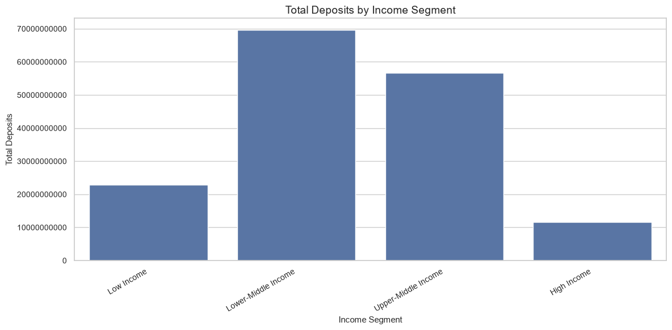
Figure 2. Total deposits by income segment

3.3 Engagement opportunity
28,604 customers combine a high total balance (at or above 285,665, the 75th percentile) with very low activity (four or fewer transactions, the 25th percentile). Examples include customers 507739 (5.72 M balance, 4 transactions), 383043 (5.33 M, 3) and 759337 (5.32 M, 3). These are natural candidates for relationship-manager outreach and investment or fixed-deposit offers. The three largest depositors overall are customers 214258 (8.79 M), 439220 (8.34 M) and 514215 (7.73 M).

4. Account and Transaction Insights

4.1 Accounts and deposits
Total deposits are 160.70 billion across 1.3 million accounts (1.3 accounts per customer). Savings is the most popular account type with 55% of accounts and deposits. The average balance is almost identical across account types, so the differences in total balance come from the number of accounts, not from richer customers.
Account type | Accounts | Share | Total balance (B) | Avg balance
Savings | 715,617 | 55.0% | 88.45 | 123,605
Current | 233,461 | 18.0% | 28.89 | 123,727
Salary | 220,913 | 17.0% | 27.49 | 124,455
Fixed Deposit | 130,009 | 10.0% | 15.86 | 122,013

4.2 Transactions
- Deposits are the largest transaction type (1.10 M transactions worth 6.35 B), ahead of withdrawals (1.00 M, 5.76 B). Deposits exceed withdrawals by 0.58 B (about 10%), a positive net inflow.
- The average transaction is about 5,770 for every type and every channel; transaction types and channels differ in volume, not in ticket size.
- Monthly transaction value stayed between about 0.49 B and 0.55 B (85,000–95,000 transactions a month) from January 2022 to June 2026, with February the lowest month each year.
Channel | Transactions | Share | Total value (B)
Mobile | 1,249,084 | 25.0% | 7.22
Internet Banking | 900,633 | 18.0% | 5.18
ATM | 898,711 | 18.0% | 5.18
POS | 749,858 | 15.0% | 4.34
QR | 601,405 | 12.0% | 3.48
Branch | 600,209 | 12.0% | 3.46

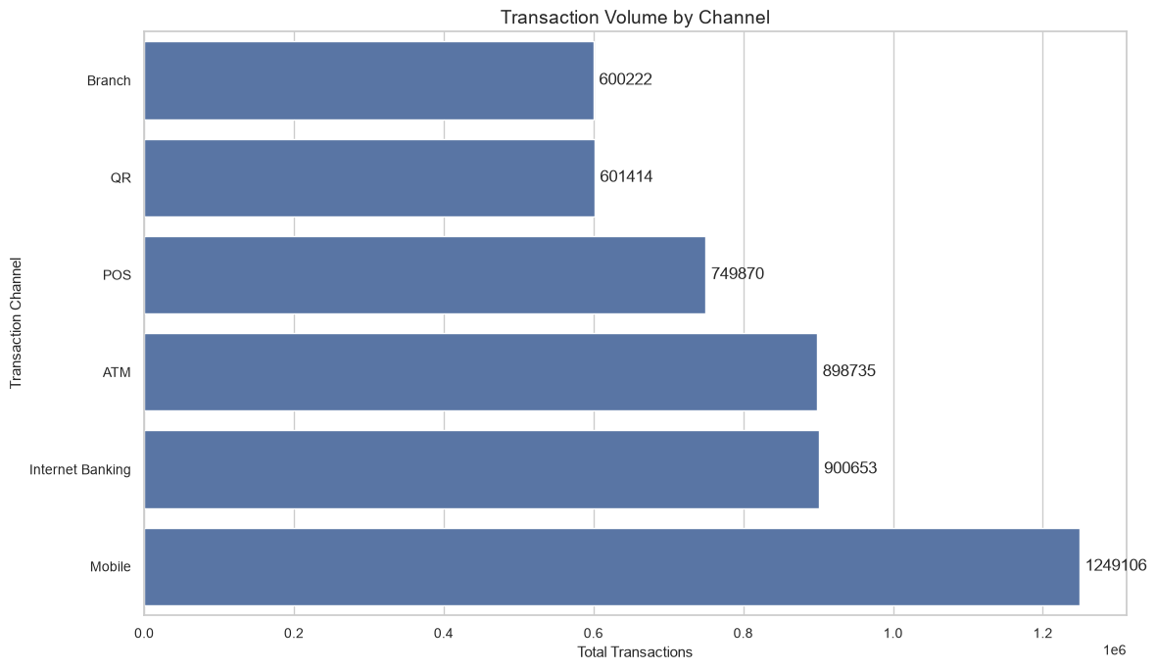
Figure 3. Transactions by channel with percentage share
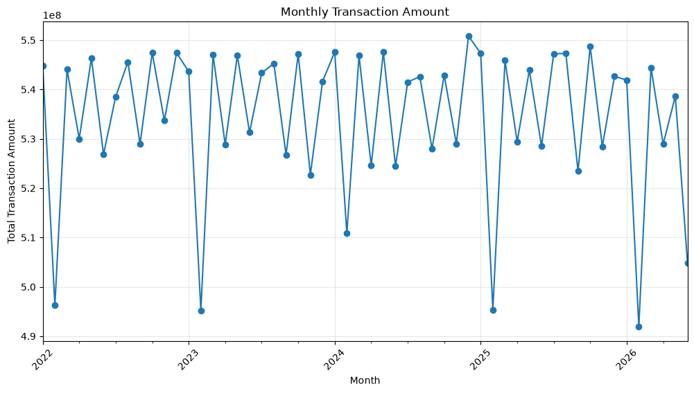
Figure 4. Monthly transaction amount, January 2022 – June 2026

4.3 Monthly deposit trend (Q24)
Account balances grouped by the month the account was opened fluctuate between 1.39 billion (February 2023) and 1.65 billion (May 2021) per month, with no sustained growth or decline. The pattern repeats yearly, with February lowest because it has the fewest days. This measures balances on accounts by opening month, not monthly deposit inflows (see Section 10).
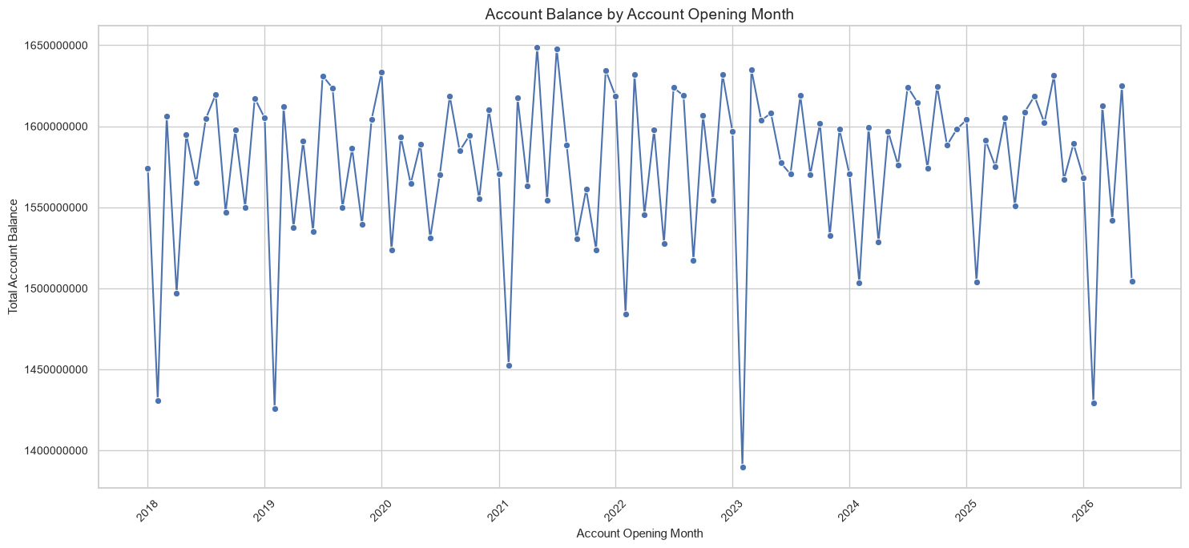
Figure 5. Account balances by account-opening month

5. Loan Insights

5.1 Portfolio overview
The bank has issued 500,000 loans totalling 524.41 billion. The average loan is 1,048,824, while the median is 698,801, so a minority of large loans lifts the average. Loan sizes range from 50,000 to 30,000,000. Average repayment so far is 48.3% of the loan amount.
Loan type | Loans | Share | Total amount (B) | Avg loan
Personal | 140,045 | 28.0% | 146.32 | 1,044,802
Home | 90,614 | 18.1% | 95.10 | 1,049,475
Business | 84,806 | 17.0% | 89.14 | 1,051,153
Auto | 74,399 | 14.9% | 78.47 | 1,054,665
Education | 60,085 | 12.0% | 62.84 | 1,045,809
Agriculture | 50,051 | 10.0% | 52.55 | 1,049,891

Most popular loan type (Q19): Personal loans, with 140,045 loans (28.0%). Average loan size is about 1.05 million for every type, so popularity is a matter of volume. Loan counts are also spread evenly across customer cities (about 33,000 loans each), led by Butwal (33,866 loans, 35.46 B).
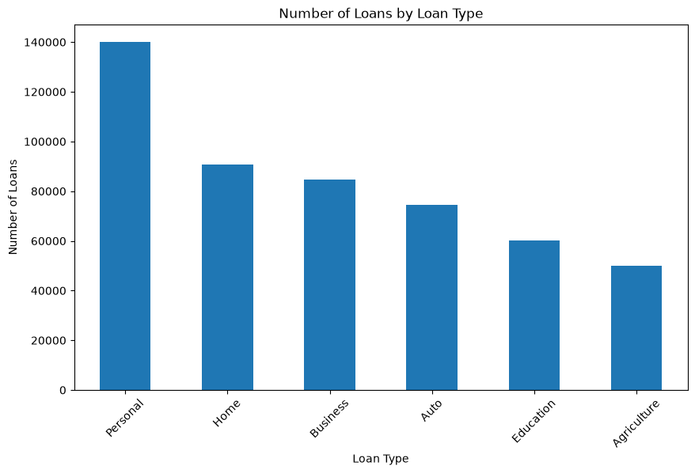
Figure 6. Number of loans by loan type

5.2 Loan status
Status | Loans | Share
Active | 200,430 | 40.1%
Completed | 149,717 | 29.9%
Approved | 60,036 | 12.0%
Defaulted | 49,843 | 10.0%
Rejected | 39,974 | 8.0%

Most loans are performing or repaid: 70% are Active or Completed. One in ten loans has defaulted. Note that the 524.41 billion total includes Rejected loans (8% of loans), so the amount actually lent is lower.
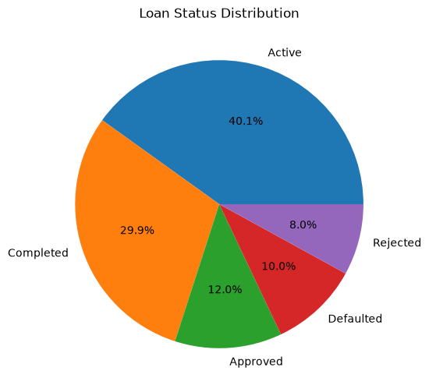
Figure 7. Loan status distribution

5.3 Do higher-income customers take larger loans? (Q21)
No. The correlation between income and loan amount is 0.0016, effectively zero. Average loan size is 1.043 million for Low-income, 1.049 million for Lower-Middle, 1.051 million for Upper-Middle and 1.050 million for High-income customers. Interest rate is also unrelated to loan amount.
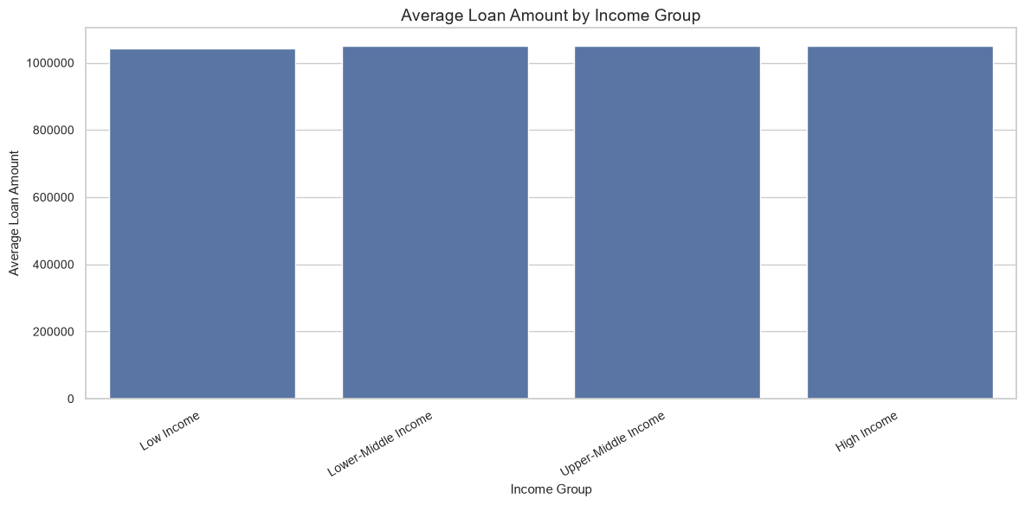
Figure 8. Average loan amount by income group

5.4 Monthly lending trend (Q25)
Monthly loan value moved between 5.29 billion (February 2021, 5,123 loans) and 6.24 billion (May 2024, 5,859 loans) over January 2019 – June 2026. Month-on-month changes swing between roughly −10% and +10% but reverse the next month; there is no sustained growth. February is a recurring low point.
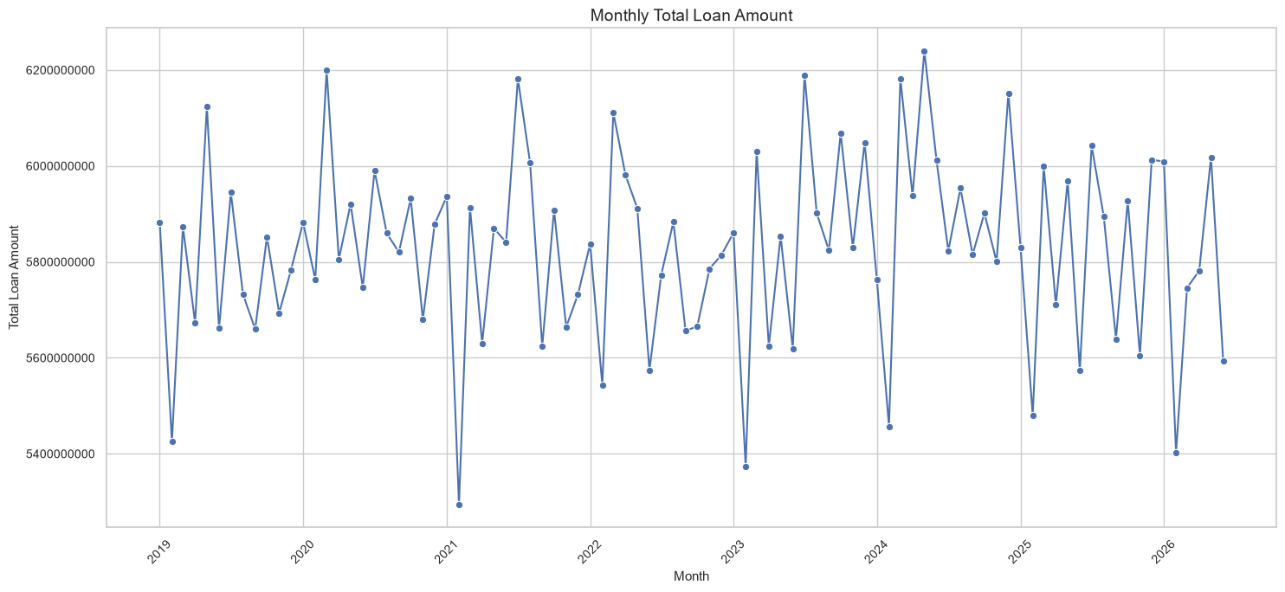
Figure 9. Monthly loan amount trend

5.5 Customers with the highest loan exposure (Q20)
Customer ID | Total loan amount | Loans | Income
252802 | 34,752,151 | 3 | 23,262
506279 | 32,380,484 | 3 | —
513481 | 30,716,707 | 2 | 42,365
108276 | 30,561,316 | 2 | 40,110
375221 / 978220 / 537465 | 30,000,000 each | 1 each | —

The largest exposures are 30–35 million, about 30 times the average loan. Customer 252802 combines the largest exposure with a low income of 23,262.

6. Branch Insights
The bank has 50 branches. Deposits are measured from accounts held at each branch. The loans file has no branch field, so loan activity is estimated through customers’ account branches, which makes branch loan figures indicative rather than exact.

6.1 Highest deposits (Q17)
Rank | Branch | Total deposits (B) | Accounts | Avg balance
1 | BR039 | 3.275 | 26,067 | 125,625
2 | BR047 | 3.268 | 26,177 | 124,830
3 | BR012 | 3.265 | 26,148 | 124,871
4 | BR027 | 3.261 | 25,972 | 125,551
5 | BR007 | 3.258 | 25,906 | 125,778

BR039 generates the highest deposits. The top ten branches are within 1.3% of each other (3.27 B down to 3.23 B), so deposit performance is very even.
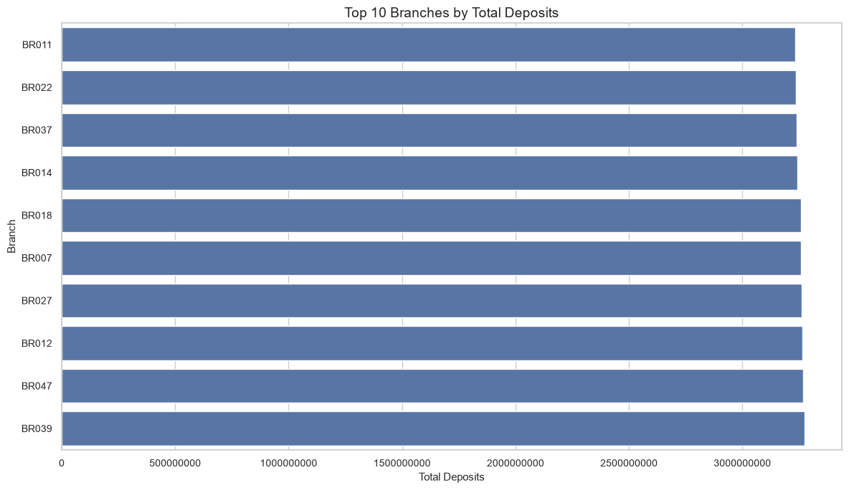
Figure 10. Top 10 branches by total deposits

6.2 Highest loan activity (Q18)
By loan value, BR024 leads with 13.92 billion across 13,036 loans, followed by BR010 (13.87 B) and BR004 (13.80 B). By loan count, BR004 leads with 13,214 loans, followed by BR012 (13,138) and BR010 (13,094). The branch with the largest loan value is therefore not the one with the most loans. Because a customer with accounts at several branches is counted at each of them, these figures overstate each branch’s own lending.
Correction to the source notebook: the written answer to Q18 names BR010 as having the most loans, but the notebook’s own chart and table show BR004 (13,214) ahead of BR012 and BR010. This report uses BR004.
BR039, the deposit leader, ranks only about 15th by loan value (13.62 B, 12,812 loans), so the largest deposit branch is not a lending leader.

6.3 High deposits but low loan activity (Q22)
Branches were flagged when deposits were high and loan activity low. Two different assignment methods were used, and they agree on BR027 and BR007:
Branch | Deposits (B) | Loans (estimated) | Flagged by
BR027 | 3.261 | 7,215 | Both methods
BR007 | 3.258 | 7,178 | Both methods
BR014 | 3.242 | 7,253 | Q22 analysis
BR049 | 3.233 | 7,227 | Q22 analysis
BR040 | 3.232 | 7,287 (EDA method) | EDA analysis
BR035 | 3.231 | 7,059 | Q22 analysis
BR030 | 3.228 | 7,228 | Q22 analysis
BR003 | 3.227 | 7,259 | Q22 analysis
BR019 | 3.221 | 7,194 | Q22 analysis

BR027 and BR007 are the strongest candidates for a lending-growth review, because they hold large deposits but lend less than most peers. BR035 has the lowest loan count among the flagged branches.
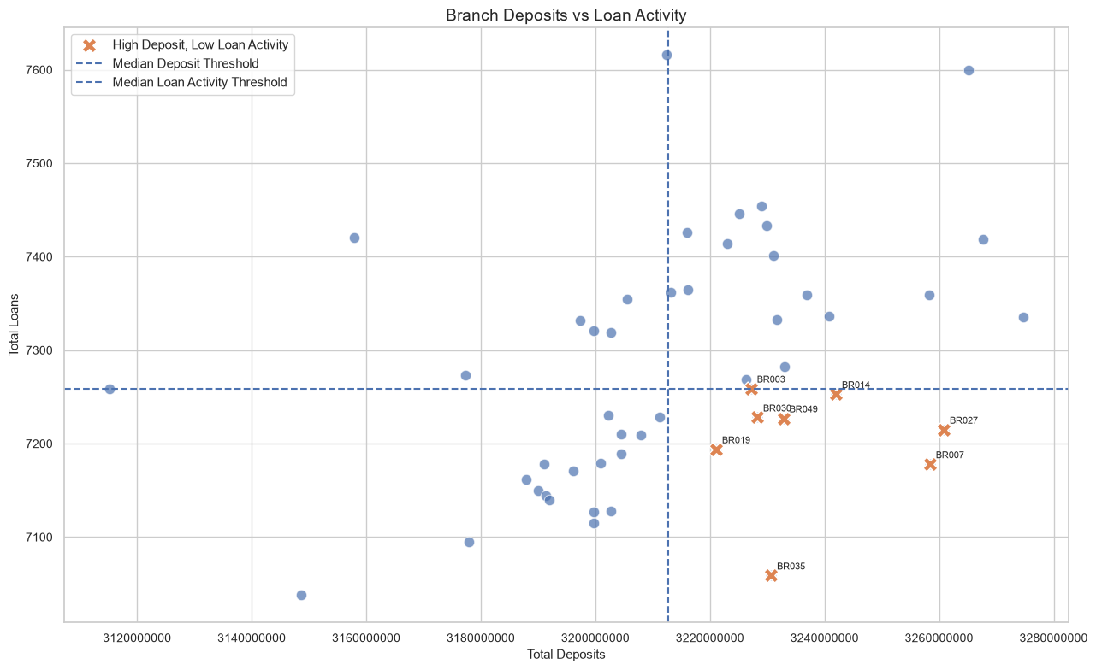
Figure 11. Branch deposits versus loan activity (median thresholds)

7. Risk Insights
Risk was examined from three angles: actual loan status, a rule-based customer score, and a repayment screening flag. These are screening indicators for management attention, not confirmed credit losses.

7.1 Portfolio level
49,843 loans (9.97% of all loans, or 10.8% of loans excluding Rejected) have defaulted, and 40.1% are still active, so a further share of the book remains exposed. Average repayment is 48.3% of loan value.

7.2 Rule-based customer risk score
Each customer earns points for five indicators (maximum 8): high total loan amount (+2), low income (+2), poor repayment (+2), multiple loans (+1) and high estimated outstanding balance (+1). Scores of 0–2 are Low, 3–4 Medium and 5–8 High.
Risk indicator | Customers | Threshold used
High loan amount | 250,000 | Total loans ≥ 628,939 (top 25%)
High outstanding balance | 250,000 | Estimated outstanding ≥ 256,771 (top 25%)
Low income | 249,751 | Income ≤ 31,068 (bottom 25%)
Poor repayment | 98,278 | Average repayment ratio ≤ 0.257 (bottom 25% of borrowers)
Multiple loans | 90,505 | Two or more loans

The high-loan and high-outstanding counts equal exactly 250,000 because they are percentile cut-offs by design; they are not findings in themselves.
Risk category | Customers | Share
Low Risk Indicator (score 0–2) | 742,399 | 74.2%
Medium Risk Indicator (score 3–4) | 153,537 | 15.4%
High Risk Indicator (score 5–8) | 104,064 | 10.4%

The ten largest high-risk exposures include customers 252802 (income 23,262; 34.75 M across 3 loans), 513481 (42,365; 30.72 M; 2 loans), 108276 (40,110; 30.56 M; 2 loans), 978220 (54,924; 30.0 M) and 926680 (59,715; 27.24 M). These accounts deserve individual review.

7.3 Repayment screening (Q23)
A simpler screen flags customers whose repayment ratio is below 50% or whose loan status suggests trouble. It flags 228,923 of 393,109 borrowers (58.2%). This figure is inflated because Rejected loans have zero repayment and were included; it is a broad watch-list, not an estimate of expected defaults. The score in 7.2 is the better guide to priority.
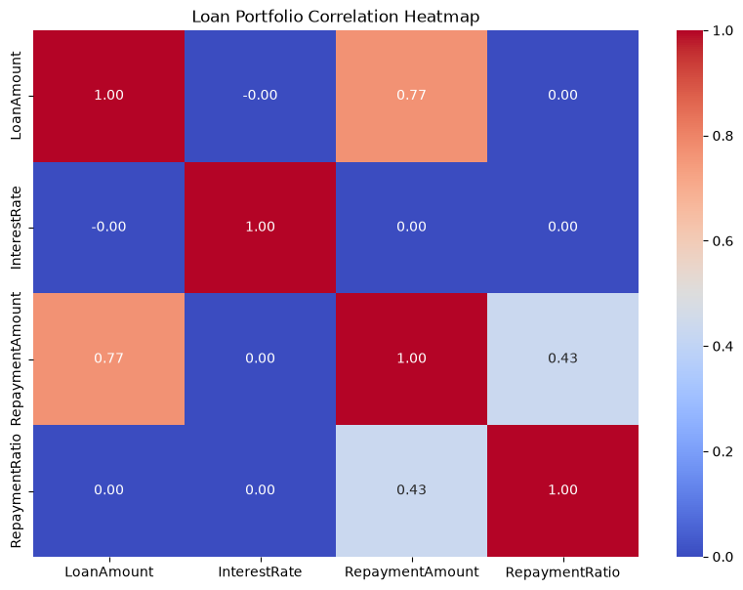
Figure 12. Correlation heatmap of loan variables

7.4 Patterns that stand out
- Income and interest rate do not predict repayment: correlation between interest rate and repayment ratio is 0.0012, and the repayment ratio is 0.481–0.484 in every interest-rate group. Interest rates are therefore not currently priced to risk in a way the data can detect.
- Some very large exposures sit with modest incomes: the top exposure holder earns 23,262 against 34.75 million borrowed. This is one example, not a portfolio-wide pattern.
- Multiple borrowing is a material factor: 90,505 customers hold two or more loans, which adds to their combined exposure.

8. Answers to the Final Business Questions
# | Question | Answer
16 | Most valuable customer segment? | Lower-Middle Income: 43.3% of customers, deposits and loans. Value per customer is equal across segments.
17 | Branch with highest deposits? | BR039: 3.27 B across 26,067 accounts (BR047 and BR012 follow).
18 | Branch with highest loan activity? | BR024 by value (13.92 B); BR004 by count (13,214 loans). Estimated through customer accounts.
19 | Most popular loan type? | Personal: 140,045 loans (28.0%).
20 | Highest loan exposure? | Customer 252802: 34.75 M across 3 loans; then 506279 (32.38 M).
21 | Do high-income customers take larger loans? | No. Average loan is 1.04–1.05 M in every income group; correlation 0.0016.
22 | High deposits, low loan activity? | BR027 and BR007 (flagged by both methods); also BR014, BR049, BR040, BR035, BR030, BR003, BR019.
23 | Higher repayment risk? | 104,064 customers (10.4%) carry a High Risk Indicator; 228,923 borrowers (58.2%) are flagged by the broader screen.
24 | Monthly deposit change? | Fluctuates 1.39–1.65 B by account-opening month; no sustained trend.
25 | Monthly loan change? | Fluctuates 5.29–6.24 B a month; no sustained trend; peak May 2024.
26 | Most popular channel? | Mobile: 24.98% of transactions.
27 | Segments to target for new products? | Lower-Middle and Upper-Middle (78% of customers); also the 28,604 high-balance, low-activity customers.

9. Recommendations
- Build products around the middle-income majority. Lower-Middle and Upper-Middle customers hold 78% of deposits and loans. Develop affordable savings and personal-loan bundles for the first group and premium savings and investment products for the second. Validate demand with a customer survey before launch.
- Invest in mobile and digital banking. Mobile (25%) and Internet Banking (18%) already handle 43% of transactions. Prioritise mobile features, digital onboarding and digital cross-selling; review the cost-to-serve of branch (12%) and ATM (18%) channels.
- Re-engage 28,604 high-balance, low-activity customers. Assign relationship managers and offer fixed-deposit, investment or premium account products. These customers already hold large balances but rarely transact.
- Set up a credit-risk watch-list. Monitor the 104,064 High Risk Indicator customers, starting with the largest exposures (customers 252802, 513481, 108276). Introduce exposure limits for single borrowers near the 30 M ceiling.
- Tighten risk assessment beyond income and interest rate. Neither predicts repayment in this data. Use repayment behaviour, outstanding balance and number of loans in credit scoring, and review whether interest rates are priced to risk.
- Review default drivers by loan type. With 9.97% of loans defaulted, analyse default rates by loan type, branch and segment (not yet done) before expanding Personal loans, which are 28% of the book.
- Launch lending campaigns at BR027 and BR007. Both hold large deposits but lend less than peers. Target existing depositors with suitable loans, and learn from BR024, BR004 and BR010, which lead on lending.
- Revive customer acquisition. New customers are flat at about 9,800 a month since 2018, and February is always the weakest month. Run referral and seasonal campaigns, especially around February.
- Grow stable funding. Fixed Deposits are only 10% of accounts and 9.9% of deposits. Promote term deposits to reduce reliance on easily withdrawn balances, particularly given the high loan-to-deposit ratio.
- Improve data capture for the next phase. Record the originating branch on each loan, true outstanding balances, days past due and actual deposit inflows by month, and fix the branch-ID casing issue before building SQL tables and Tableau dashboards.

10. Limitations and Next Steps
- Near-uniform patterns. Many distributions (city, occupation, branch, loan type) are almost perfectly even and correlations are near zero. This is unusual for real banking data and suggests the dataset may be simulated; conclusions should be re-tested on live data.
- Loan book versus deposits. Total loans (524.4 B) are about 3.3 times deposits (160.7 B). The loan total includes Rejected and Approved-but-not-necessarily-disbursed loans and ignores repayments, so this ratio should be validated before it is used for liquidity decisions.
- Branch loan attribution. Loans have no branch field. Two proxy methods were used and they give slightly different results, so branch lending rankings are indicative.
- Deposit trend. Q24 groups balances by account-opening month. It is not a measure of monthly deposit inflows, which would need the transaction table.
- Risk measures. Outstanding amount is estimated as loan amount minus repayment, and all thresholds are project rules rather than regulatory standards. Scores identify customers for review; they do not confirm credit loss.
- Profitability. Value is measured by deposits and loans only. Interest income, costs and fees were not available, so profitability is not assessed.
Next steps: load the cleaned data into SQL (week 3), build the four Tableau dashboards (week 4), and add default-rate analysis by loan type, branch and segment.

